OUTPUT:

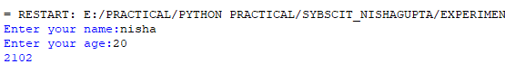

**CONCLUSION: A SIMPLE PROGRAM CAN BE RUN TO ENTER THEIR NAME & THEIR AGE.**